**Problem Statement**

The problem statement for this project can be summarized as follows: To provide a comprehensive analysis and summary of tourism and travel trends in India, focusing on various aspects such as popular tourist destinations, seasonal travel patterns, cost analysis of top cities, and revenue contributions from different cities.

**Aim**

The aim of this project is to:

1. Identify popular tourist destinations in India based on seasonal travel patterns.
2. Analyse the costliness of various cities in terms of tourism.
3. Highlight the top cities contributing to tourism revenue.
4. Provide insights into popular activities associated with each city during different tourist seasons.
5. Present a geo-representation of key tourist attractions.

**Data Collection-**

The data collected from Chat GPT.

**Data Visualization**-

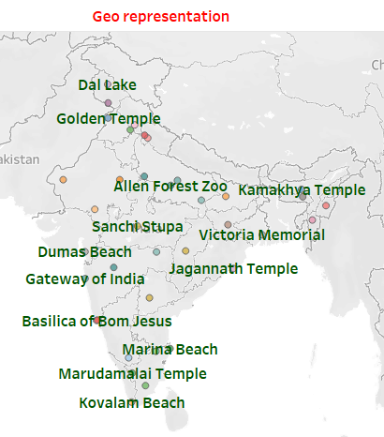

This chart is a geographical representation of various notable landmarks across India. Each landmark is plotted on the map of India at its respective location. Here's a brief description of each landmark:

1. **Dal Lake** - Located in Srinagar, Jammu & Kashmir, it is known for its houseboats and scenic beauty.
2. **Golden Temple** - Situated in Amritsar, Punjab, it is a significant pilgrimage site for Sikhs.
3. **Allen Forest Zoo** - Found in Kanpur, Uttar Pradesh, it is one of the largest zoos in India.
4. **Kamakhya Temple** - Located in Guwahati, Assam, it is an important Hindu temple dedicated to the goddess Kamakhya.
5. **Sanchi Stupa** - An ancient Buddhist monument located in Sanchi, Madhya Pradesh.
6. **Victoria Memorial** - A grand marble building in Kolkata, West Bengal, built in memory of Queen Victoria.
7. **Dumas Beach** - A popular urban beach located along the Arabian Sea in Surat, Gujarat.
8. **Gateway of India** - A historic arch-monument in Mumbai, Maharashtra.
9. **Jagannath Temple** - A famous Hindu temple dedicated to Jagannath in Puri, Odisha.
10. **Basilica of Bom Jesus** - Located in Goa, it is famous for housing the mortal remains of St. Francis Xavier.
11. **Marina Beach** - One of the longest urban beaches in the world, located in Chennai, Tamil Nadu.
12. **Marudamalai Temple** - A popular hill temple dedicated to Lord Murugan, located in Coimbatore, Tamil Nadu.
13. **Kovalam Beach** - A renowned beach in Kovalam, Kerala.

These landmarks are diverse, ranging from religious temples to natural sites and historical monuments, each highlighting a unique aspect of India's rich cultural and geographical heritage.



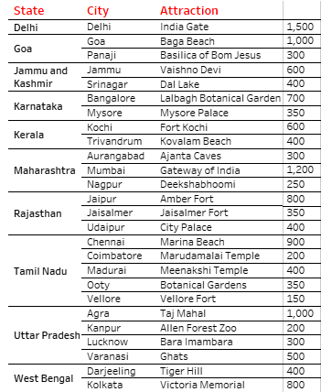

This chart is a tabular representation of various tourist attractions across different states and cities in India. The table lists the states, their corresponding cities, notable attractions in those cities, and Number of visitors to visit in these states, this is a visitor counts Here’s a detailed breakdown:

**Delhi**

* **City:** Delhi
  + **Attraction:** India Gate
  + **Number of visitors:** 1,500 thousand

**Goa**

* **City:** Goa
  + **Attraction:** Baga Beach
  + **Number of visitors:** 1,000 thousand
* **City:** Panaji
  + **Attraction:** Basilica of Bom Jesus
  + **Number of visitors:** 800 thousand

**Jammu and Kashmir**

* **City:** Jammu
  + **Attraction:** Vaishno Devi
  + **Number of visitors:** 600 thousand
* **City:** Srinagar
  + **Attraction:** Dal Lake
  + **Number of visitors:** 400 thousand

as so on.

This table offers a concise summary of key tourist spots in various regions of India, potentially helping travellers or researchers quickly identify significant attractions in each location.

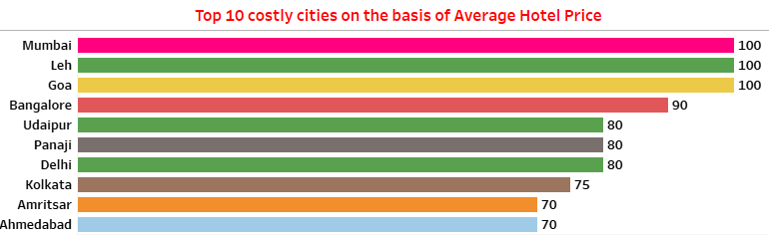

This bar chart illustrates the top 10 most expensive cities in India based on average hotel prices. The cities are listed in descending order of cost, with the highest average hotel prices at the top. Each bar represents a city's relative cost, with the length of the bar indicating the average price.

Here's a breakdown of the chart:

1. **Mumbai**: 100
2. **Leh**: 100
3. **Goa**: 100
4. **Bangalore**: 90
5. **Udaipur**: 80
6. **Panaji**: 80
7. **Delhi**: 80
8. **Kolkata**: 75
9. **Amritsar**: 70
10. **Ahmedabad**: 70

Key Points:

* **Top Three**: Mumbai, Leh, and Goa are the most expensive cities with an average hotel price index of 100.
* **Moderately Expensive**: Bangalore has an average hotel price index of 90.
* **Other Cities**: Udaipur, Panaji, and Delhi have an index of 80, indicating relatively lower but still high costs.
* **Least Expensive Among the Top 10**: Kolkata, Amritsar, and Ahmedabad have the lowest average hotel price indices in this list, at 75 and 70, respectively.

The chart provides a visual comparison, helping to quickly identify which cities have the highest average hotel prices for traveller.

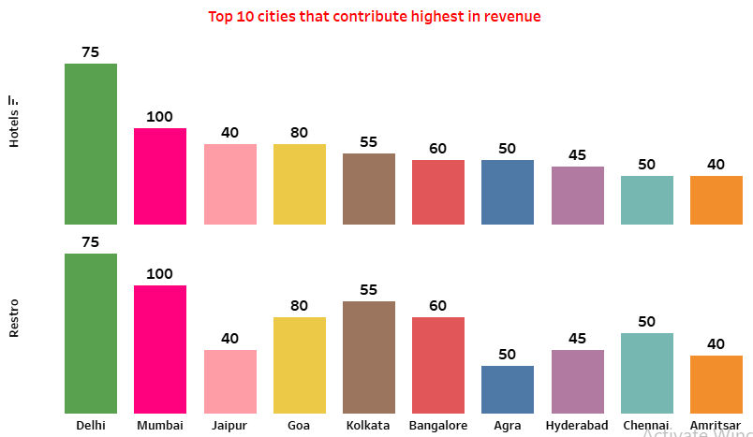

This bar chart shows the top 10 cities in India that contribute the highest revenue from two sources: hotels and restaurants. The cities are listed along the x-axis, while the revenue contribution is on the top of the bars and numbers of hotels and restaurants is shown on the y-axis. The chart is divided into two sections: one for hotels and one for restaurants.

Mumbai is a leading highest state in revenue which is followed by Goa and Delhi.

Above bar chart represents, Delhi is a leading state having 500 hotels which is followed by Mumbai and Jaipur 300 and 250 respectively. Amritsar is the least in hotels having 180.

Below bar chart represents Delhi is a leading state having 500 Restaurant which is followed by Mumbai and Jaipur 400 and 350 respectively. Amritsar is the least in hotels having 150.

**Key Points:**

* **Top Contributors**: Mumbai is the top contributor for both hotels and restaurants with the highest revenue of 100 million.
* **Delhi**: Highest no of both hotels and restaurants in Delhi have a revenue of 75 million.
* **Consistent Contributors**: Cities like Jaipur, Goa, Kolkata, Bangalore, Agra, Hyderabad, Chennai, and Amritsar appear in both categories with varying indices.
* **Balanced Revenue Contribution**: Cities like Delhi, Mumbai, and Goa have balanced contributions from both hotels and restaurants.
* **Variance in Contributions**: While most cities show similar rankings in both categories, the exact revenue index varies, highlighting specific strengths in either hotels or restaurants.

This chart provides a visual comparison of the revenue contributions from hotels and restaurants across these top cities, helping identify key markets and potential areas for investment or development.



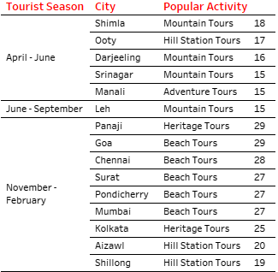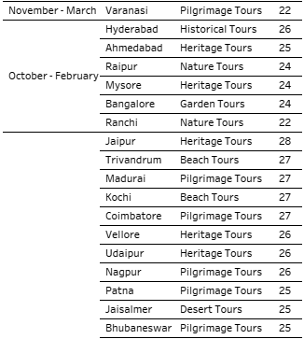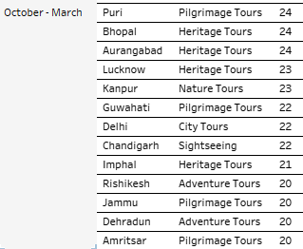

This table lists various tourist destinations in India along with their popular activities, categorized by the best tourist seasons based on temperature. Here's a breakdown of the information:

**Interpretation:**

* **April - June**: Popular for mountain and hill station tours in cooler destinations like Shimla, Ooty, Darjeeling, Srinagar, and Manali.
* **June - September**: Ideal for beach and heritage tours in coastal and culturally rich cities such as Goa, Panaji, Chennai, and Kolkata. Mountain tours in Leh are also popular.
* **November - February**: Favourable for beach tours in western and southern cities, heritage and historical tours in Kolkata, Ahmedabad, Hyderabad, and pilgrimage tours in Varanasi.
* **October - February**: Another peak period for a mix of nature, heritage, and pilgrimage tours in places like Raipur, Mysore, and Varanasi.

Dashboard -

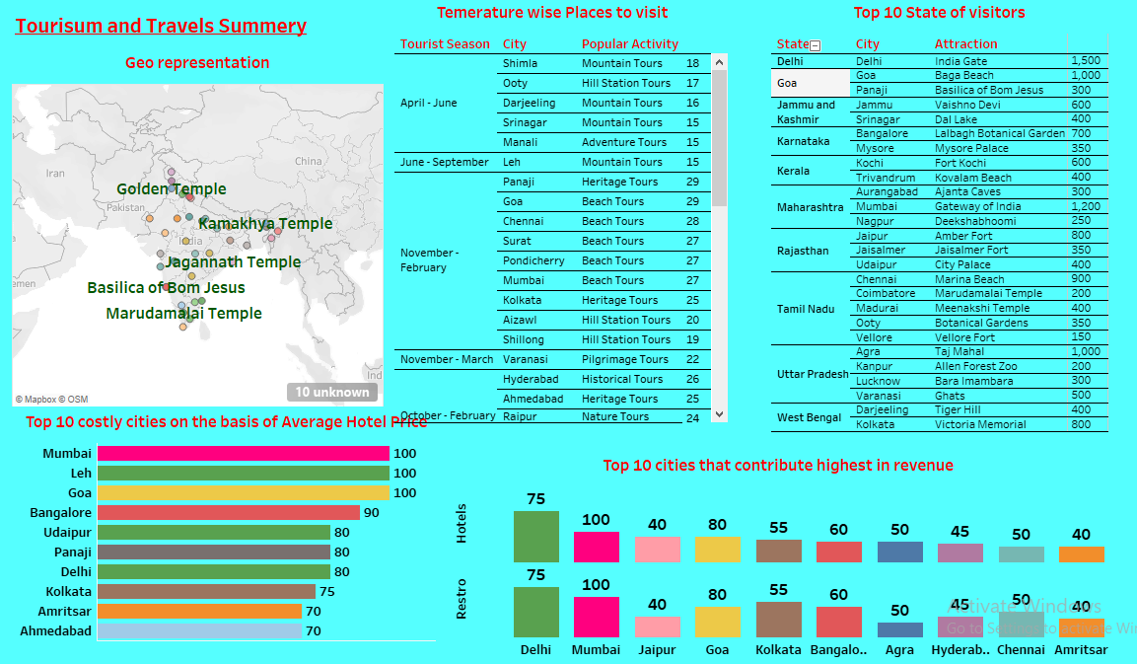

**Recommendations**

Based on the analysis provided by the dashboard, the following recommendations can be made:

1. **Promotional Strategies:** Focus on promoting cities like Delhi, Goa, and Mumbai which are top contributors to tourism revenue.
2. **Seasonal Packages:** Create customized travel packages that align with the peak tourist seasons for various cities (e.g., mountain tours in Shimla during April-June, beach tours in Goa during June-September).
3. **Cost Management:** Address the costliness of cities like Mumbai and Leh by providing budget-friendly options or special discounts.
4. **Diversify Attractions:** Encourage tourism in less visited but significant places like Aizawl and Coimbatore by highlighting their unique attractions.
5. **Infrastructure Development:** Improve infrastructure in high-revenue cities to accommodate more tourists comfortably.

**Outcomes**

1. **Increased Tourist Inflow:** By aligning promotional activities and packages with tourist preferences, there could be an increase in the number of tourists visiting India.
2. **Enhanced Revenue:** Targeted marketing and better infrastructure could lead to higher tourism revenue.
3. **Balanced Tourism:** Promoting lesser-known destinations could balance the tourist inflow across the country, preventing overcrowding in popular areas.
4. **Improved Tourist Experience:** Better infrastructure and cost management could lead to an improved overall experience for tourists.

**Conclusions**

The dashboard provides valuable insights into the current tourism and travel trends in India. By leveraging this data, stakeholders can make informed decisions to enhance the tourism sector. Focused marketing, improved infrastructure, and strategic planning based on seasonal trends and city-specific attractions can lead to increased tourist satisfaction and higher economic benefits for the country.